Creation of a New Home Security System Using IoT Devices

*Nathan Cottrell*

*University of Portsmouth*

*Portsmouth*

[*up2109768@myport.ac.uk*](mailto:up2109768@myport.ac.uk)

**Abstract** — This project presents the design and implementation of a moderately low-cost portable smart home door and window security system using IoT devices. This report outlines the devices used and why each was chosen compared with alternative devices for each situation, an outline of the rough costs for each component needed to create the device, pseudo code, diagrams to show logic and data flow within the device and a final implementation made with available devices including a reflection on how the project went.

**Index Terms** — Internet of Things (IoT), home security, HC-SR04 ultrasonic sensor, Camera, smart devices, motion detection, real-time notification, intrusion detection, image capture, buzzer alarm system, pseudocode, logic diagram, smart home, design, implementation.

—————————— ◆ ——————————

# 1 Introduction

## Scenario

C

onsider a scenario where someone attempts to break into a home. Without an effective home security system in place, it may go undetected. This is a reality many people face. With a house being broken into approximately every 173 seconds in 2023/24 (Office for National Statistics, 2022)home security is becoming an increasing concern for UK citizens. Due to this IoT based smart home devices are gradually becoming more popular among the public with approximately "one in five Brits now own[ing] a video doorbell" (Buccieri, 2025) this rise in popularity is primarily due to the increased capabilities and affordability of these devices.

Many traditional home security systems can either be expensive or complex to install and many low-cost alternatives lack the capabilities to be truly effective. This demonstrates the need for a simple, effective home security system which was not be overly expensive.

## Solution

This was where a simple portable system which could be installed at any door or window in a property could come in useful. The system included a sensor to detect when a door opens and use a camera to snap a picture of the intruder before sending a notification to the user’s phone and then waiting for a bit to allow for the person to input a pin before setting off an alarm. This device was meant to scare the intruder to stop them from entering while still ensuring that they get caught due to the image capturing capabilities.

# 2 Details of the design

## Hardware components

T

he system could be split into three sections:

Firstly, there was the trigger mechanism which was made up of a HC-SR04 ultrasonic sensor rigged up directed at the door in order to detect a change in the distance from it to the door and send a signal to the next section of the device.

This was better as opposed to the other options, such as a button positioned such that when the door was fully closed it would be pressed and when opened it would stop pressing the button. This was because while being effective it would be difficult to implement reliably.

Furthermore, a tilt sensor attached to the door so when it moves the sensor would trigger, due to the change in the angle, this would be able to be implemented easily enough. However, an issue with this approach was that while optimal it was currently not in possession of the developer.

|  |  |
| --- | --- |
| **Tilt Sensor**  *(Gravity: Digital 360° Tilt Sensor, 2025)* | **Ultrasonic sensor**  *( Ultrasonic Distance Sensor (HC-SR04), 2025)* |
| Working Voltage: 3.3~5V. | Power Supply:  5V |
| Range:  Only what it is  attached to | Range:  2cm – 400cm/4m |
| Connector:  Gravity. | Working  Frequency: 40Hz |
| Tilt Switch Angle: 45°±10° | Measuring Angle: 15 degree |
| Module Size:  22*30mm / 0.87*1.18 inches. | Dimensions: 43mm x 20mm x 15mm |
| Price:  £2.40 | Price:  £2.00 |

Table 1: Tilt and ultrasonic sensor comparisons

Secondly, there was the camera and email notification using the OV2640 which waited for a few seconds to allow for the door to be fully opened before taking a picture and sending it to the user's phone as a notification.

The OV2640 would be the better choice over the other option which would have involved using an OV7670 camera module due to the OV7670 not supporting compressed images and offering lower resolution as opposed to the OV2640 (Jackson, 2021).

|  |  |
| --- | --- |
| **OV2640** | **OV7670** |
| Array size:  1600 x 1200 | Array size:  640 x 480 |
| Output format:  YUV/RGB/Raw RGB Data/MJPEG | Output format:  YUV/RGB/GRB/Raw RGB Data |
| Pixel size:  2.2 x 2.2 μm | Pixel size:  3.6 x 3.6 μm |
| Image transfer rate:  1600×1200@15fps, SVGA@30fps, CIF@60fps | Image transfer rate:  VGA@30fps |
| Power consumption  125mW | Power consumption  60mW |
| Power consumption:  Core: 1.3V DC ± 5% Analog: 2.5~3.0V DC I/O: 1.7V to 3.3V | Power consumption:  Core: 1.8V DC ± 10% Analog: 2.45~3.0V DC I/O: 1.7V to 3.0V |
| Price:  More expensive | Price:  Cheaper |

Table 2: OV2640 vs OV7670 comparison (Jackson, 2021)

To send a notification to the user, the chosen option was to utilise SMTP to send an email to the user's phone. This approach would not require any specialist hardware and could be done entirely through code (Email: Examples — Python 3.7.3 Documentation, 2019).

On the other hand, another method of sending notifications to the user includes using an ESP8266 to create a web server to display data and send notifications through Pushover which was a notification service that integrates with many applications (Santos, 2023). This choice was not chosen due to the time restraints around this project.

Lastly, there was the alarm where it then waited for a bit longer to allow the person a chance to input a pin on a membrane switch module to shut off the alarm which used a buzzer and would trigger if the pin was not put in in time. However, the buzzer would still go off if the pin was input after the timer was over.

The membrane switch was chosen over alternatives such as a 3x4 matrix array keypad or an Interfacing AS608 Optical Fingerprint Sensor Module due to the membrane switch and keypad being very similar devices and the membrane switch being easier for users as the user does not need to go through the trouble of setting up a finger print scan for everyone who was allowed in as opposed to telling them the PIN for the membrane switch.

Also, the buzzer was chosen over alternatives such as a speaker as it was unnecessary to use a speaker as opposed to a buzzer due to not requiring the extra functions provided by the speaker.

### Wiring

#### Passive Buzzer Wiring

Buzzer GND --> Arduino GND

Buzzer --> Arduino pin 13

#### HC-SR04 Ultrasonic sensor Wiring

HC-SR04 VCC --> Arduino 5v

HC-SR04 ECHO --> Arduino pin 11

HC-SR04 TRIG --> Arduino pin 12

HC-SR04 GND --> Arduino GND

#### Membrane Switch Wiring

Matrix Row 1 --> Arduino pin 3

Matrix Row 2 --> Arduino pin 4

Matrix Row 3 --> Arduino pin 5

Matrix Row 4 --> Arduino pin 6

Matrix Column 1 --> Arduino pin 7

Matrix Column 2 --> Arduino pin 8

Matrix Column 3 --> Arduino pin 9

Matrix Column 4 --> Arduino pin 10

## Software design

### Pseudo-code

#### Arduino

*Define ultrasonic sensor*

*Define buzzer*

*Define duration*

*Define distance*

*Define keypad*

*rows = 4*

*cols = 4*

*hexakeys[rows][cols] = {*

*Buttons on keypad*

*}*

*colpins[rows] = pins*

*rowpins[cols] = pins*

*void setup() {*

*Set input/output of the ultrasonic sensor*

*Set serial communication*

*Set buzzer output*

*WIFI.begin*

*}*

*void loop() {*

*Set buzzer off*

*Set ultrasonic sensor to low*

*Delay for two microseconds*

*Set ultrasonic sensor to high*

*delay for ten microseconds*

*Set ultrasonic sensor to low*

*Calculate the distance*

*Divide the speed of the sound wave by 2 (there and back)*

*if (distance>distance to door+10 or distance<distance to door-10) {*

*delay for 5 seconds*

*send serial message to python script to take picture*

*If (key pressed = #)*

*If pad = password*

*End*

*If pad != password*

*Buzzer on*

*Void read keypad() {*

*get key pressed*

*If key pressed != #*

*pad += new key pressed*

*}*

*delay 0.1 seconds*

*}*

#### Python

*Import serial*

*Import cv2*

*Import time*

*Import os*

*Import email*

*Smtp port*

*Smtp server*

*Email from*

*Email to*

*password*

*send email()*

*message from*

*message subject*

*message to*

*add body of the email*

*add Image to the email*

*Encode attachments*

*Connect to SMTP*

*Send email*

*Disconnect*

*Set serial port*

*Set directory for saved images*

*Make the directory if it does not exist*

*Open camera*

*If the camera does not work, then exit*

*while true*

*if port has information waiting*

*read data*

*if command = take picture*

*take picture*

*if picture is taken*

*timestamp = year-month-day*

*file name = image-timestamp.jpg*

*send email()*

### Logic diagram

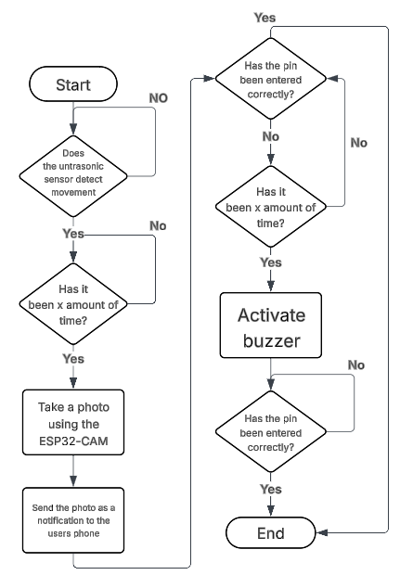

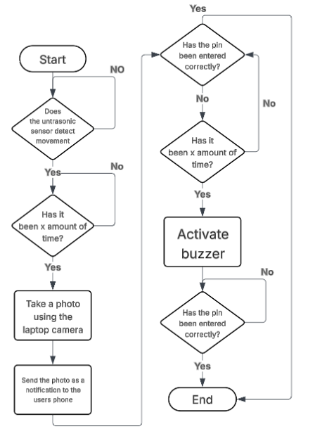

Figure 1: Logic diagram

## Working conditions

In order for the device to work it has to be pointed directly at the surface you want it to monitor with no obstructions. This allows for the

# 3 Implementation

## Limitations

Due to hardware limitations for this implementation, the device instead used an HC-SR04 ultrasonic sensor as an alternative to the tilt sensor, an Arduino board with a laptop webcam instead of an OV2640. This slightly changed how the project was implemented however these changes did not have significant effects on the functionality of the device.

## Ultrasonic sensor

To implement the ultrasonic sensor, the developer used Arduino code to send out a sound wave at the object it was pointing at thousands of times a second to maintain high accuracy and ensure responsive activation. This sound wave then returns to the ultrasonic sensor and the distance was then calculated using duration * 0.034 / 2. The code then outputs this distance for testing and clarity purposes.

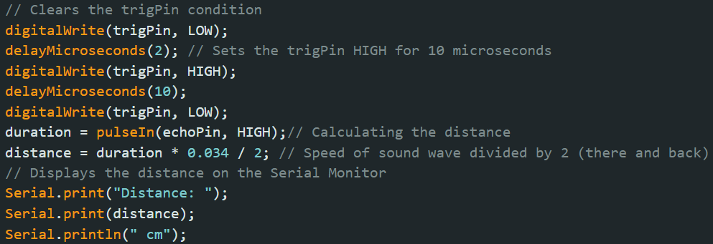

Figure 2: ultrasonic sensor distance measuring

## Buzzer

To implement the buzzer, the developer had a timer which would start counting once the ultrasonic sensor detects movement. Once this timer reaches 30 seconds it would go through the if statement as shown in figure 3. This if statement activates the buzzer for three seconds, which would be adjusted to be longer outside of an example scenario and then resets the variables and takes a new baseline reading in case the door was left open when it resets to avoid a loop.

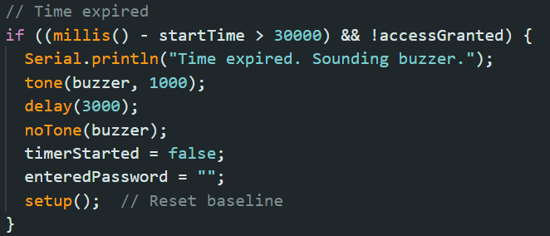

Figure 3: Code for the alarm

## Camera

To use a laptop camera to take pictures, the developer had to make the Arduino code send out a message on the connected port to make a piece of python code use the laptop camera to take a picture and save it. Furthermore, each image was saved in a folder called Captured_Images and named using a timestamp to avoid multiple files with the same name.

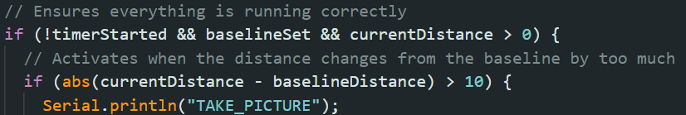

Figure 4: Code to activate the python code

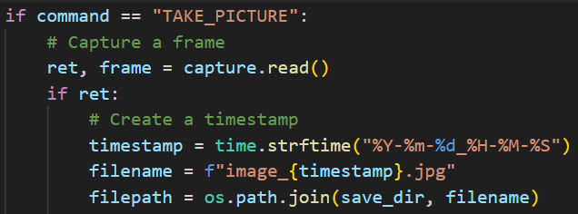

Figure 5: Code to take a picture

## Email

To implement the device having the ability to send emails, the developer had to import SMTP modules into python and get an application password for a new Gmail account. This allowed the code to connect to SMTP and attach images and text to an email to alert the user that there has been a security issue as seen in figures 6&7.

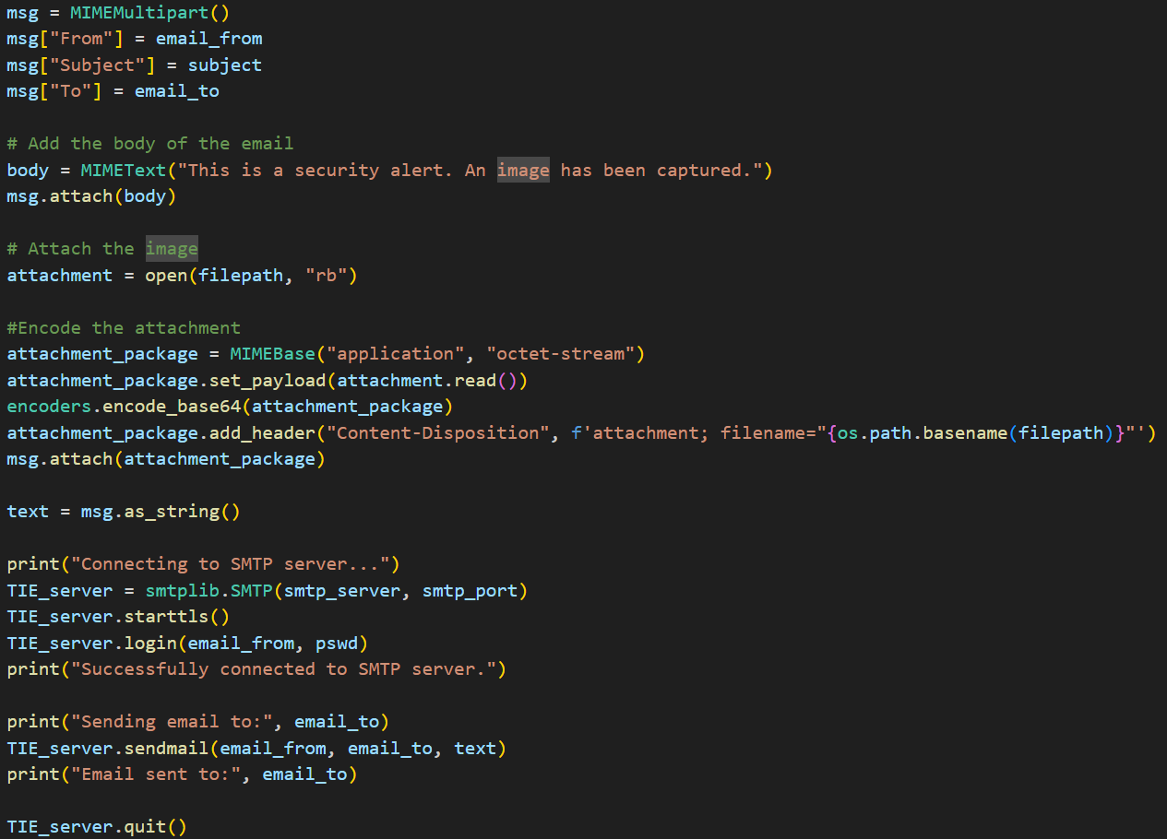

Figure 6: Email code

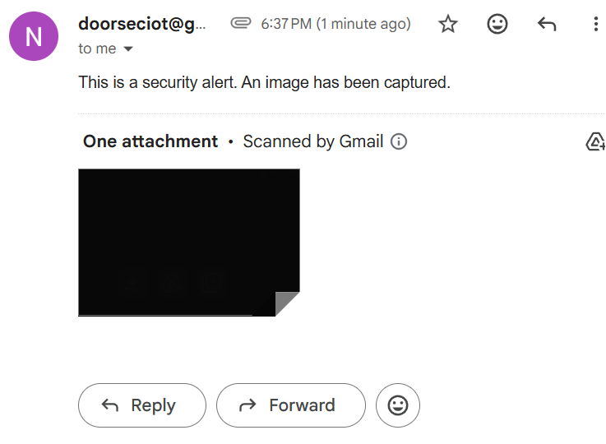

Figure 7: Email sent with attachment by code

## Keypad

To implement the keypad, the developer created a matrix which included each of the values on the keypad and then linked each row and column of the keypad to the pin it was attached to on the Arduino.

Afterwards the developer added code to check which buttons are being pressed and if, when entered, the password was correct.

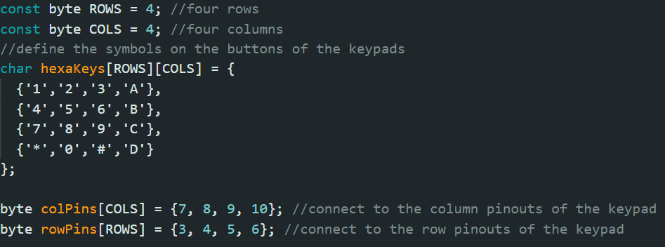

Figure 8: Code setting up the keypad

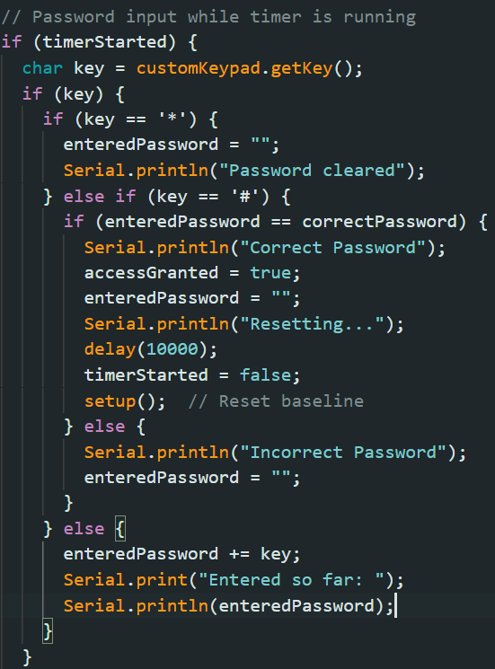

Figure 9: Code to check the password and handle inputs

## On/Off Button

To implement an on/off button the developer had to add code to check the state of the button to see if it should be on or off and then it asked the user to input the password on the keypad in order to change the device from on to off and vice versa otherwise the alarm goes off. This was done to ensure that it cannot be turned off by anyone who the user hasn't told the pin and add an extra layer of security to the device.

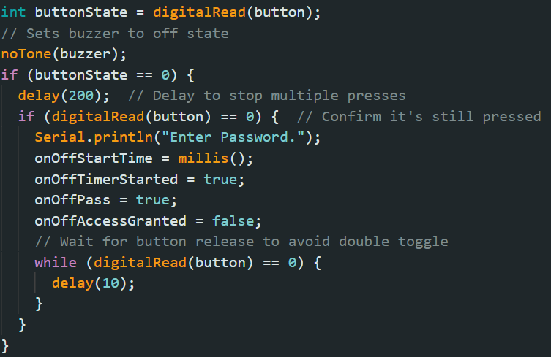

Table 3: Code to check if the button is on/off

## Wiring

To wire everything together the developer used a mixture of M-M and M-F wires with a breadboard to allow for additional connections and to attach the buzzer and resistor.

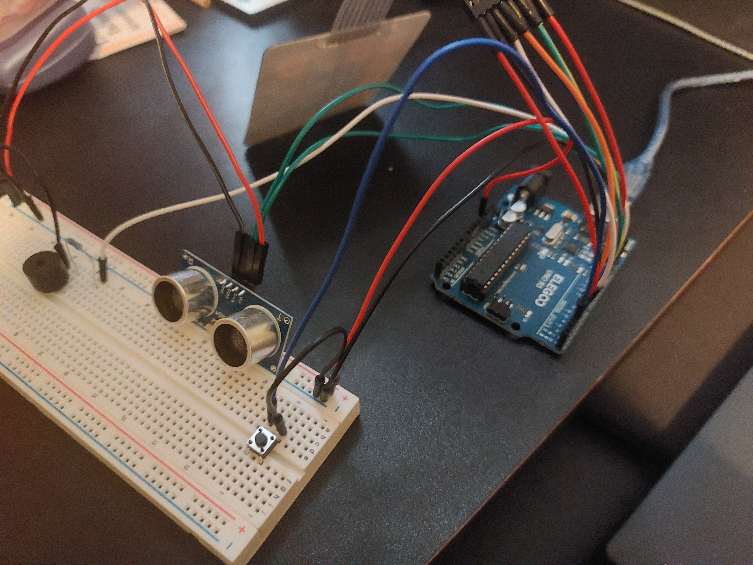

Figure 10: front image of the device wired up

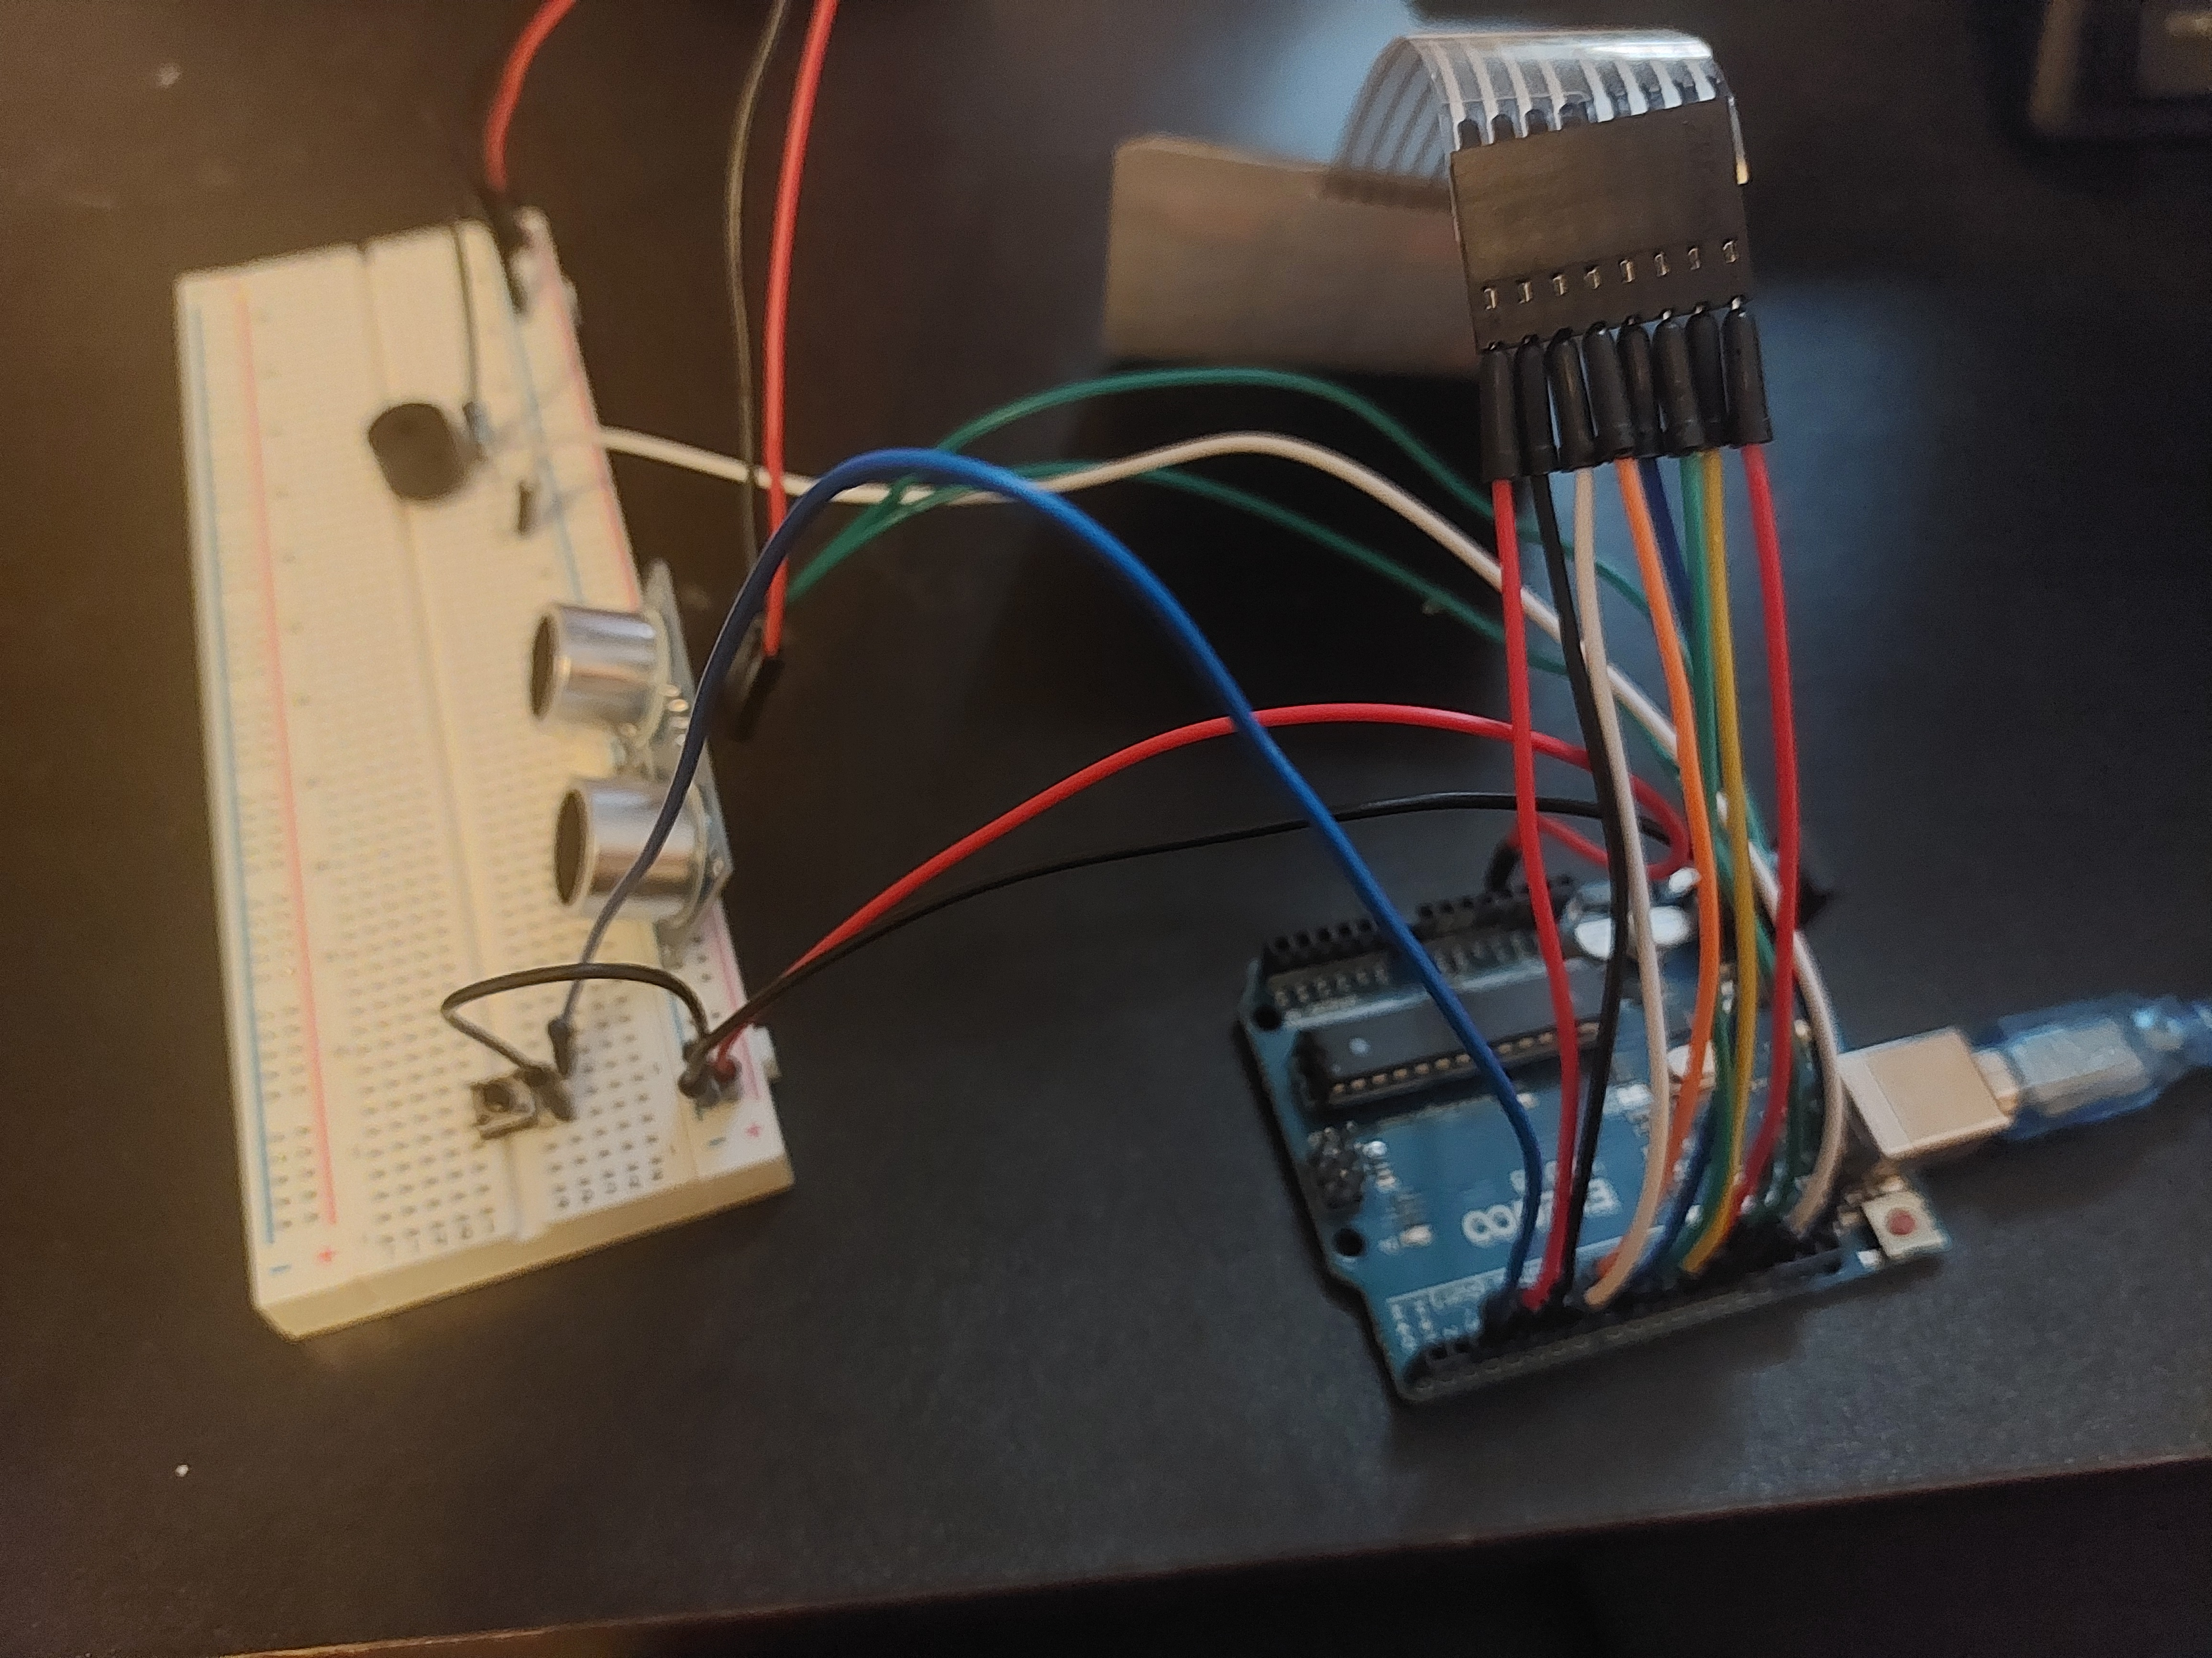

Figure 11: side image of the device wired up

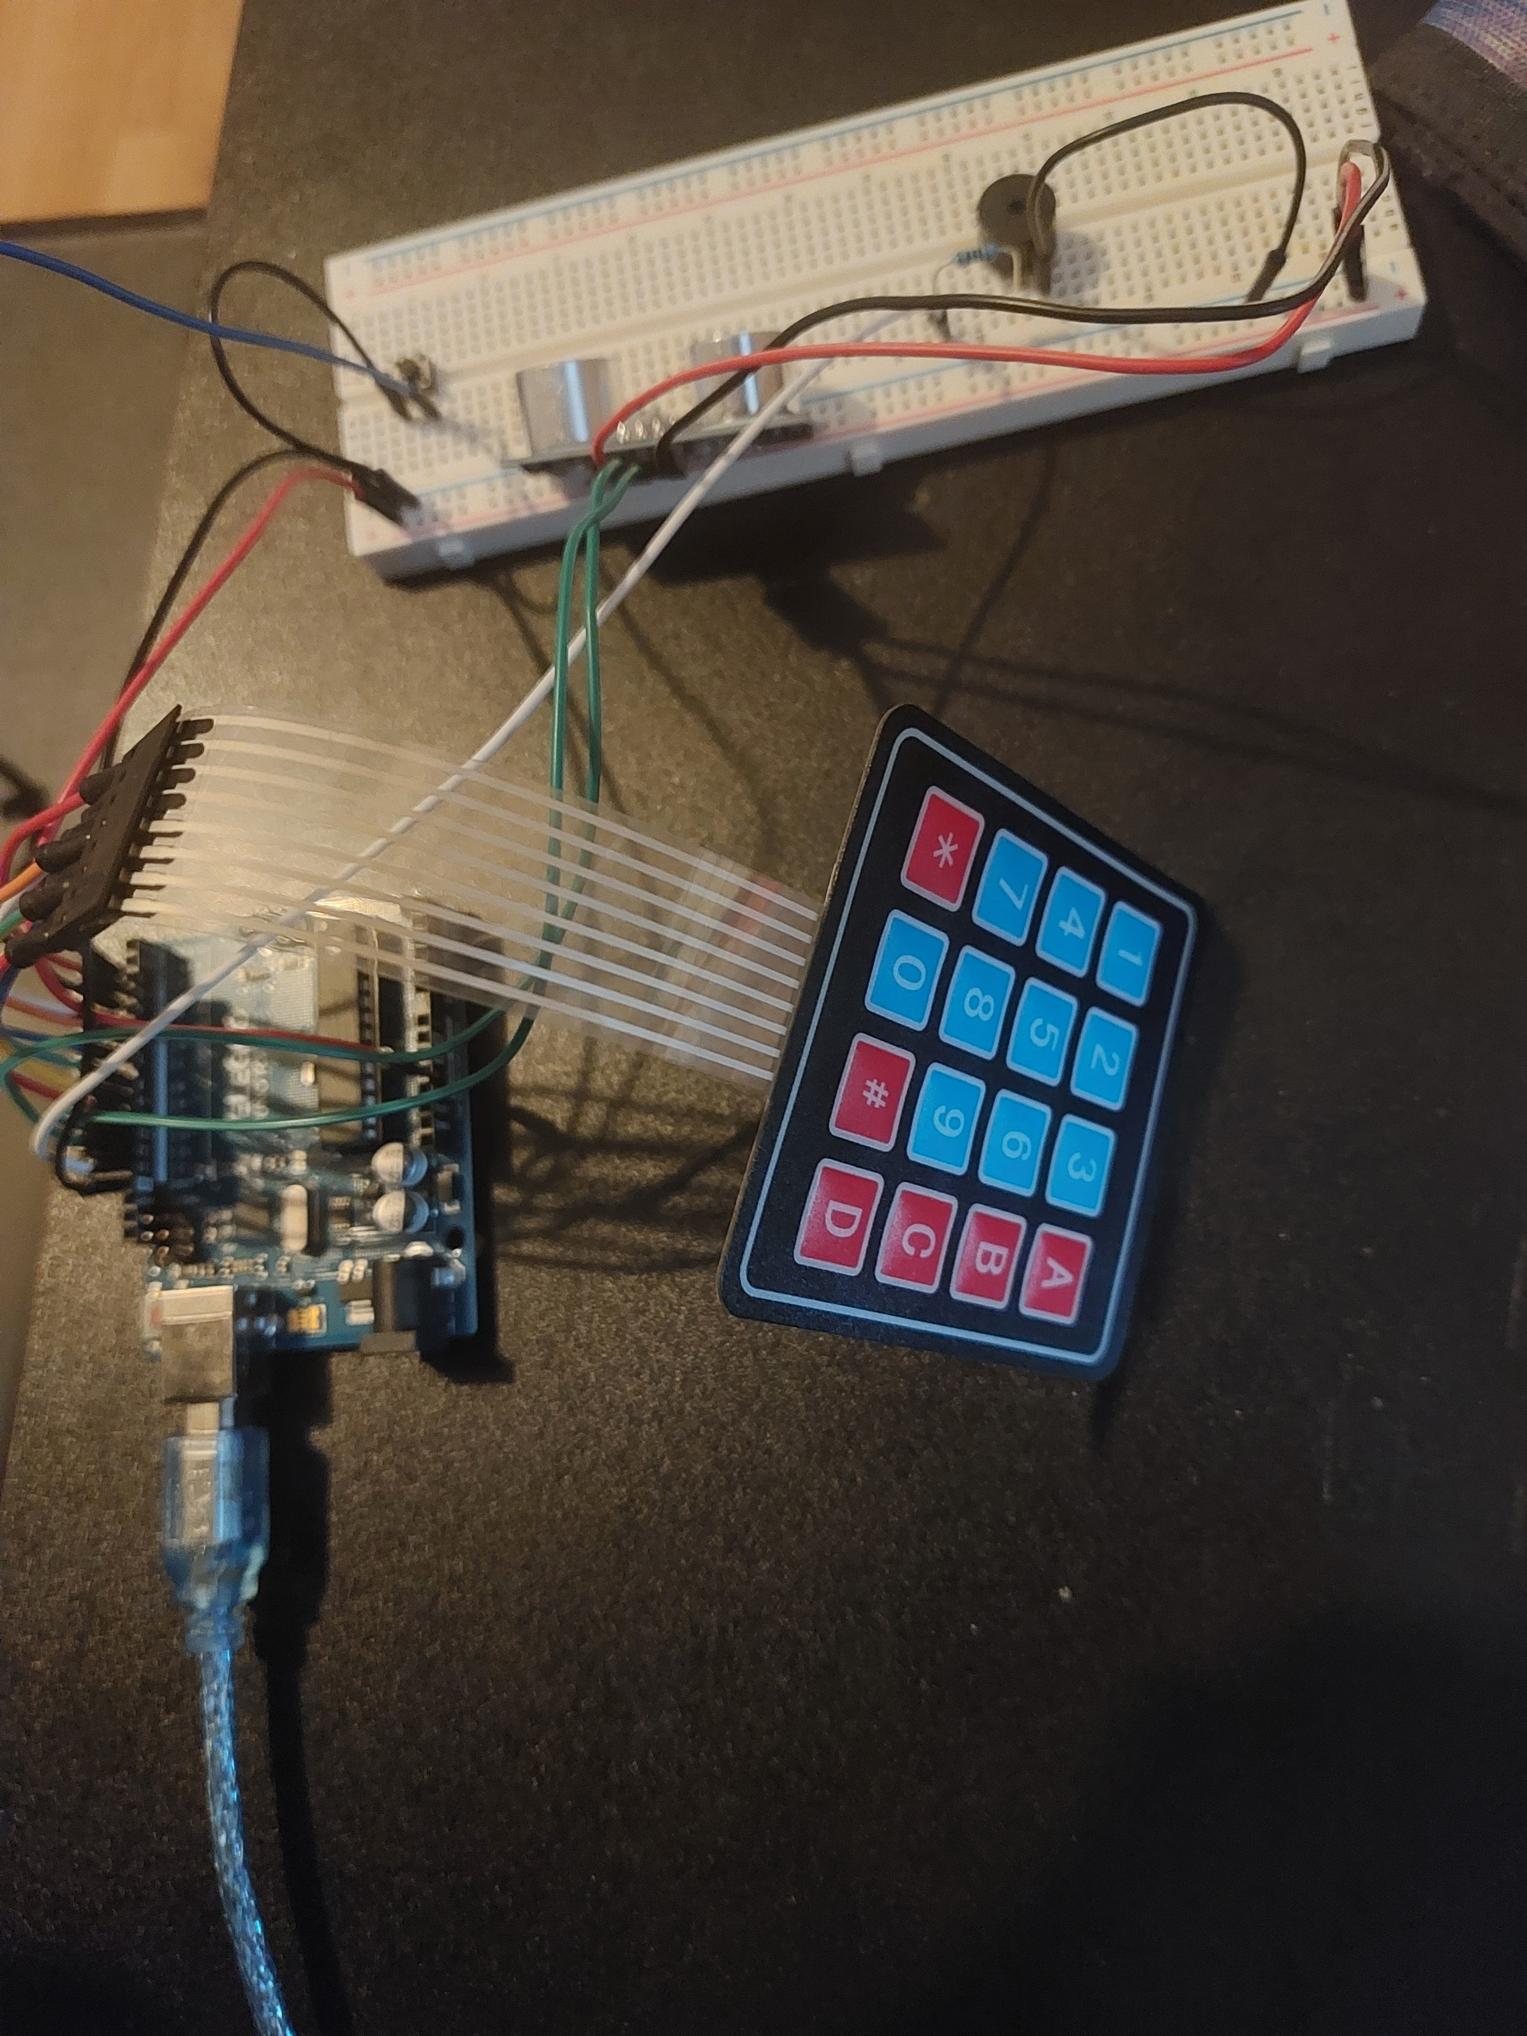

Figure 12: back image of the device wired up

# 4 Discussion and conclusion

## Summary of design

The device was an attempt to make a compact device which could be used at any entrance to the user's house to monitor if it opens. This was done through using an HC-SR04 Ultrasonic sensor to measure the distance between itself and the entrance it was meant to keep secure. This was chosen due to being able to effectively measure distances up to 4 meters and being obtainable for this project.

When it detects the entrance move it will take a picture using a laptop camera, due to the developer not having a camera module and send it to the user through SMTP.

After which the device will then start a thirty second countdown at which time the person who entered must enter a pin on a membrane switch keypad otherwise a buzzer, which was chosen due to it being the closest thing to an alarm which was obtainable, will be triggered.

## Evaluation of the device

The device accomplished most of its goals, in its current implementation could effectively monitor the entrance it was facing and activate reliably when the entrance moves.

On the other hand, it lacked portability due to the components not being contained, and user-friendliness as there is no particular front-end for the device for the user to interact with, although once the device has started working it does not need much if any interaction.

However, the biggest issue with the device is due to the ultrasonic sensor detecting distance anything that moves in front of the device would set it off. This issue primarily comes down to the device used and could probably be changed to a tilt sensor to stop these issues.

## Alternative solutions and recommendations

Throughout this report many different alternative components and approaches were discussed some of which could enhance performance, usability, or scalability. The first of which includes using a tilt sensor to detect when the entrance was moving as this would have much lower risks of false triggers.

Furthermore, the system currently uses emails for alerts. Future versions could benefit from faster more user-friendly methods such as push notifications through a mobile app.

It is recommended that future iterations explore these options in order to improve user experience and detection accuracy, while still keeping the device affordable and easily implementable for users.

## Future improvements

This device could be improved in the future by making the device smaller and utilising a casing to keep all the components together allowing for easier placement of the device by the user to watch the entrances to their house.

Another improvement would include utilising AI in order to detect if the ultrasonic sensor activating was by accident or if there is actually a possible security threat.

# 5 References

Office for National Statistics. (2022). UK Burglary Statistics (2022) - a Home Burgled Every 173s! Www.cladcodecking.co.uk. <https://www.cladcodecking.co.uk/blog/post/uk-burglary-statistics>

Buccieri, S.-M. (2025, January 23). Doorbell cameras: Do they provide peace of mind or paranoia? BBC News. https://www.bbc.co.uk/news/articles/clyzrrrrz3qo

Jackson, L. (2021). *OV2640 vs OV7670: Spec Comparison, Sample Images, Datasheets, Lens Options, Pinouts, Compatibility, and Tutorials*. [online] Arducam. Available at: https://www.arducam.com/ov2640-vs-ov7670-detailed-comparisons-and-resources/.

*email: Examples — Python 3.7.3 documentation*. (2019). Python.org. https://docs.python.org/3/library/email.examples.html

*Gravity: Digital 360° Tilt Sensor*. (2025). The Pi Hut. https://thepihut.com/products/gravity-digital-360-tilt-sensor-for-arduino

*Ultrasonic Distance Sensor (HC-SR04). (2025).* The Pi Hut. https://thepihut.com/products/ultrasonic-distance-sensor-hcsr04

Santos, S. (2023, May 18). *ESP8266 NodeMCU: Send Pushover Notifications (Arduino IDE) | Random Nerd Tutorials*. Random Nerd Tutorials. https://randomnerdtutorials.com/esp8266-nodemcu-pushover-arduino/